**Get** Data URL using Fiddler http://localhost:57875/api/tasks

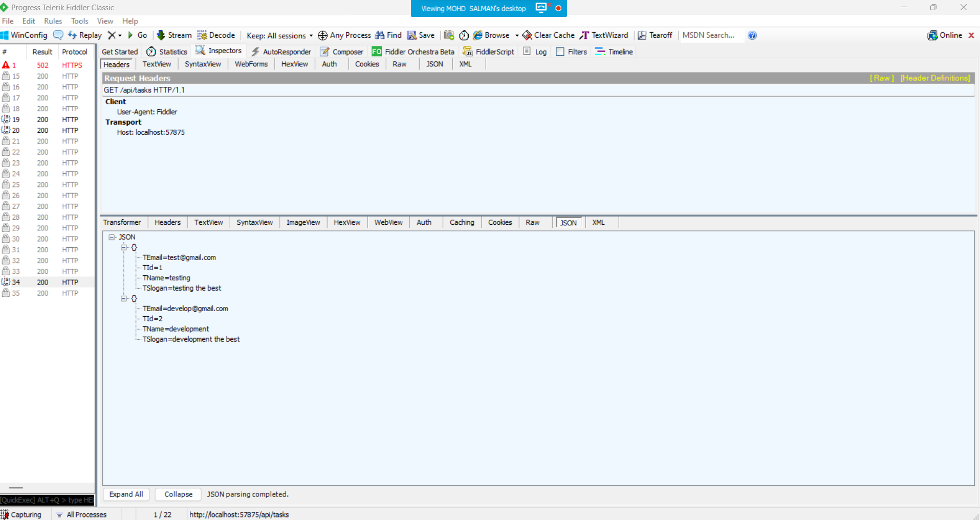

**Post** Data URL using Fiddler <http://localhost:57875/api/tasks> {"TId":0,"TName":"Deployment","TEmail":"deploy@gmail.com","TSlogan":"deploy the best"}

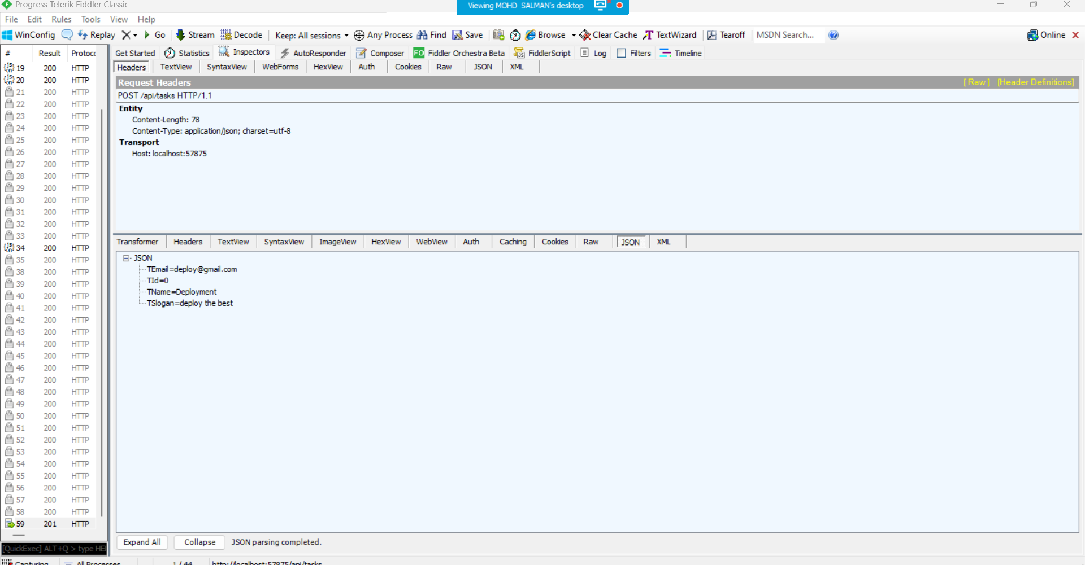

**Output**

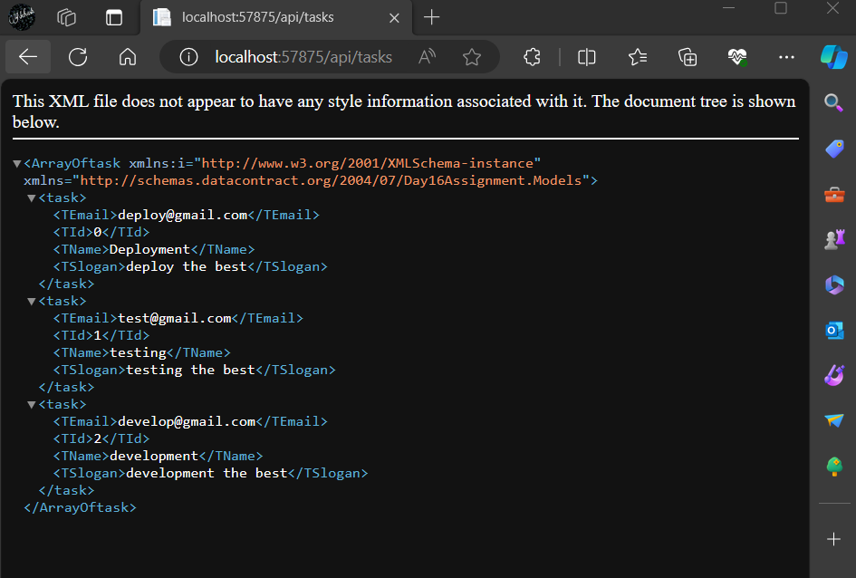

**Put** Data URL using Fiddler <http://localhost:57875/api/tasks/0>

{"TName":"DeploymentData","TEmail":"deploy@gmail.com","TSlogan":"deployment the best"}

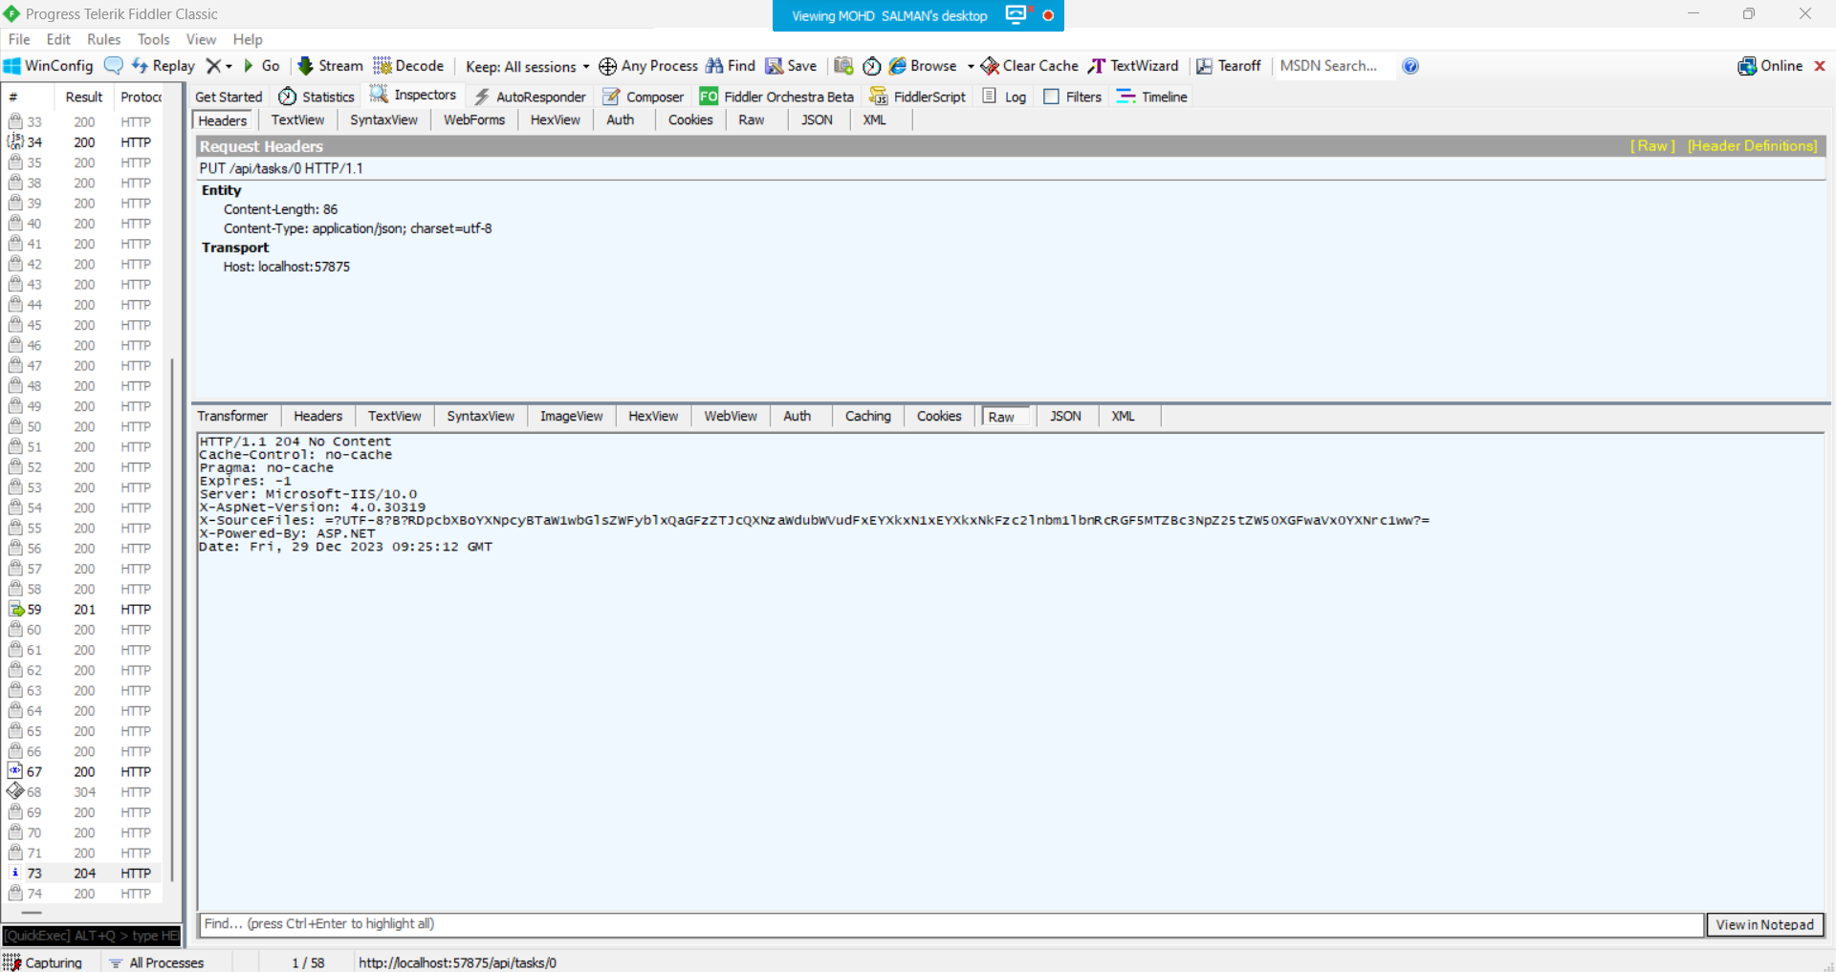

**Output**

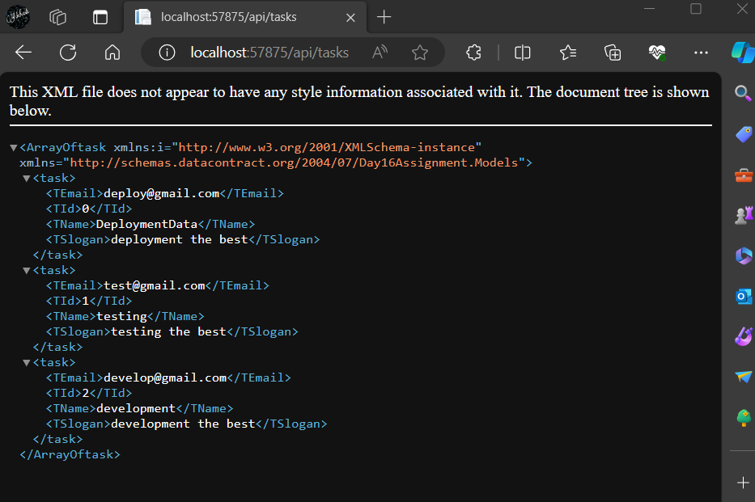

**Delete** Data URL using Fiddler <http://localhost:57875/api/tasks/0>

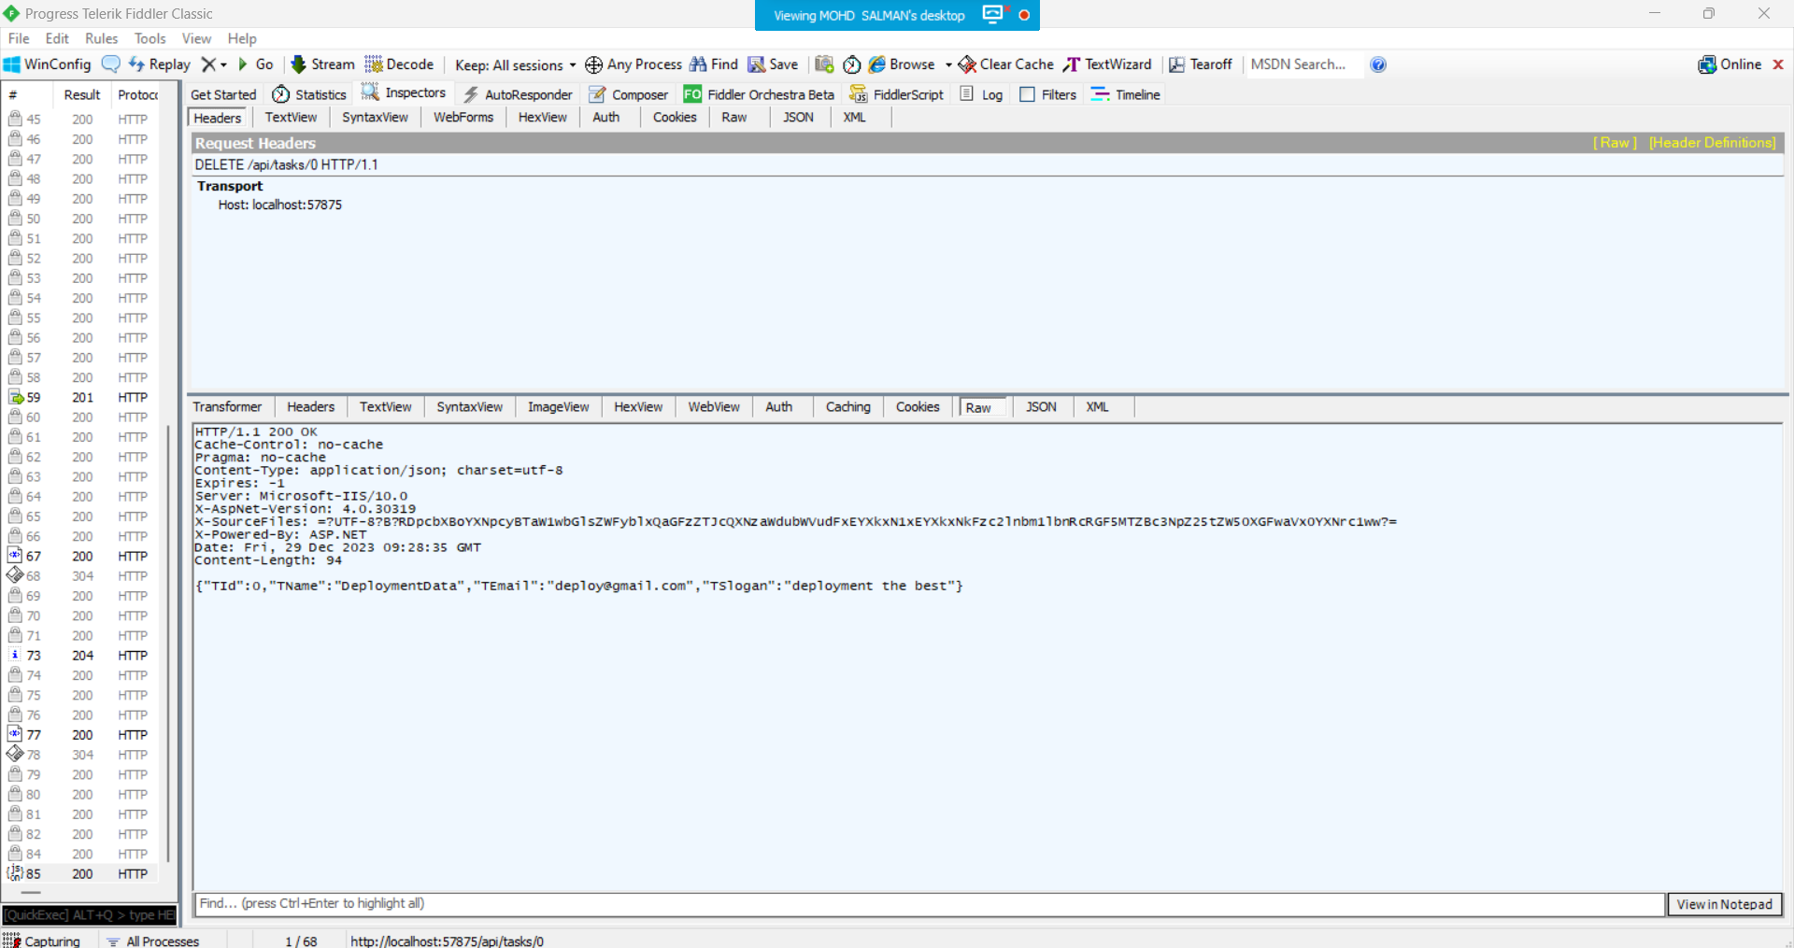

**Output**

